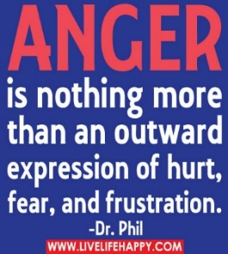
wHAT: 12 weeks group for adults
WHEN: Thursday, April 20th, 2023-
Thursday, July 13th, 2023
^{6:00 pm – 8:00 pm}
WHERE: Shalom Center
4313 39th Avenue
Kenosha, WI 53144
Enter: Door #4

WHO: Lisa L. Bowe, BA CAMF
262-818-1452 or lbowe@kafasi.org
Skills to focus on:
*Learning and understanding 4 cues to Anger * Your trigger/hooks *Understanding Stress – Awareness/Accepting/Coping *Developing an anger & stress control plan * Having positive thinking *Communicate *Learning conflict resolution

12 weeks session -once a week (self-referral – Probation/Parole – Other Agencies- Other Counties) CASH OR CASHIER CHECK
**$30.00 a session paid weekly ($300.00). Discount if paid up the first 3 weeks of class $240.00. Payments are due weekly-individuals have not paid in full by week 10, No information if completed or not will be released until balance is paid in full. Those who need information for Court will need to accept the individual did not complete the course. If participants miss more than one session it will affect the person completing the course.
